# Merchant Creation Workflow

## List of Merchants Pending for Review

The first step will be to check for merchants pending for review. The way it should work is once a Sales Representative creates a merchant in SalesForce (clients that fill our form, not leads) and the feeding from SalesForce to the new system occurs, we should see a list of the created Merchants that have not been reviewed. Then we select one of those Merchants and start the review process. Once this process starts, the system should assign and ID number to the new merchant. For example, the first merchant will be ID 1, the second ID 2, and so on.

This task can be also done manually, not only imported from SalesForce.

## Document Scanning

The second step is the Document Scanning, here we should be able to scan any document we have, but the only required document will be the Application Form, which we should be able to upload in PDF or any image format. The documents we should be able to scan are (it should allow us to scan PDFs, docs, xlsx, and any image file):

Our current Doc Scan screen looks like this (my notes in red):

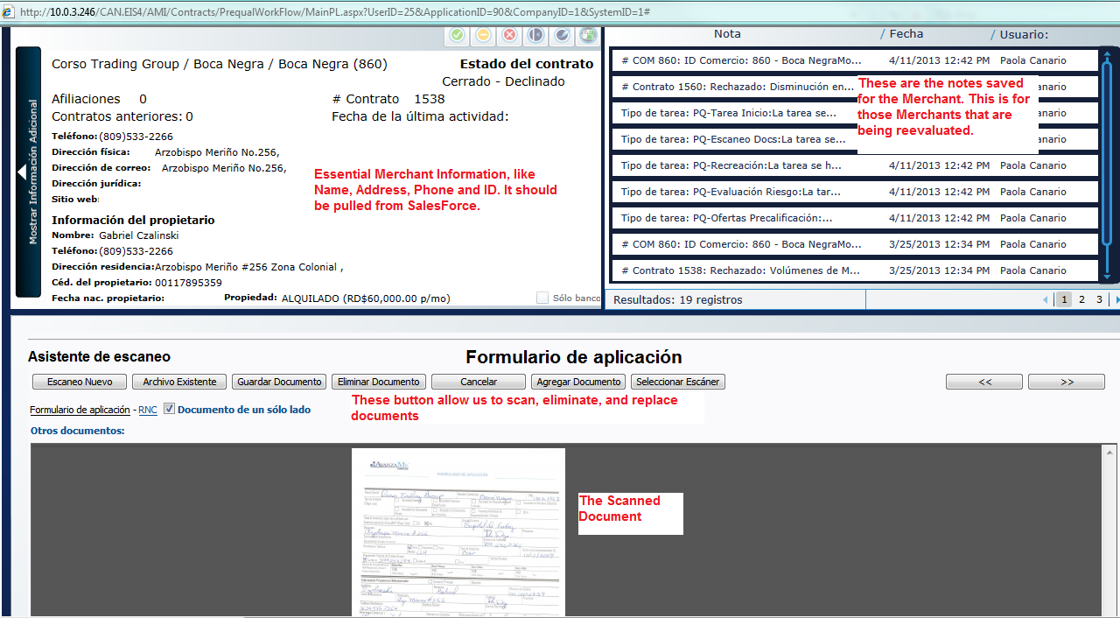

## Data Entry

The third step is the data entry. All this information should be filled from SalesForce, but we should be able to modify anything, in case we have to. The information we should have here is:

* Name of the Company
* Name of the Business
* RNC: This is the ID the government assigns to every company. It should have a maximum of 11 numbers.
* Address
* City
* Province: We will annex all the options that will make up this drop list.
* Telephone Number: Dominican telephone numbers have 10 digits in the format: (xxx) xxx-xxxx.
* Email
* Industry Type: We will annex all the options that will make up this drop list.
* Type of Property: This should be a drop list with two options, Owned and Rented.
* Rent Amount: This should be a currency field.
* Gross Yearly Sales: This should be a currency field.
* Processor Company: Either CardNet or VisaNet.
* Affiliate Number: The affiliate number for the business with either CardNet or VisaNet (or both). We should be able to add more than one affiliate number.

Then we should have the Owner’s Information in the same screen:

* Name
* Last Name
* ID or Passport Number: A maximum of 11 characters, either numbers or letters.
* Phone Number
* Cell Phone Number: In the format (xxx) xxx-xxxx.
* Address
* Email

Our current Data Entry Screen looks like this:

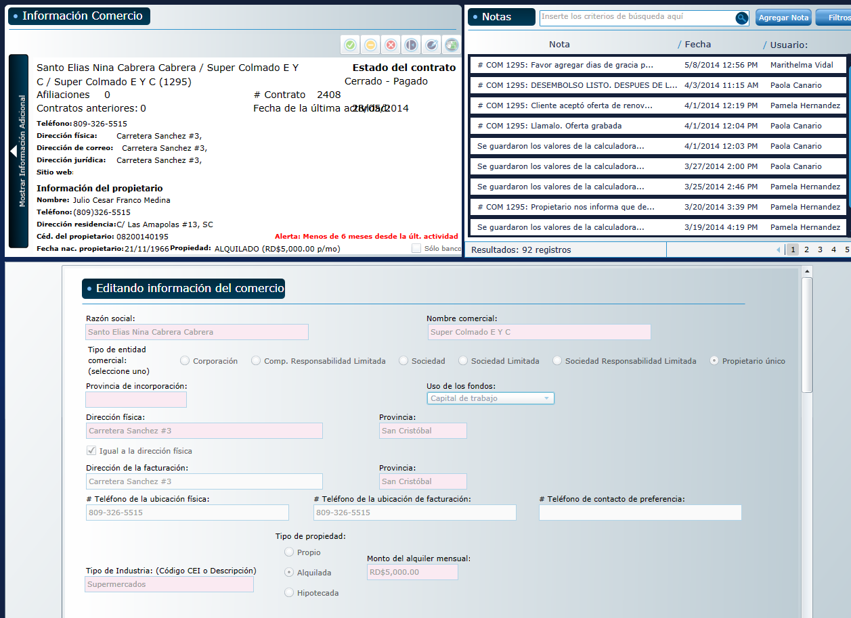

As you can see, the top part is very similar to the Doc Scan screen, and bellow is all the information I have indicated above.

## Credit Card Volumes

At this point the system should send a request to VisaNet and CardNet for the credit card volumes, then, once we receive the request, the workflow continues. There are times when we receive the volumes outside the normal process, through email or some other way, which is why we need to have the option, in our system, to manually type the credit card volumes, so that it can go on to the scoring job.

Once the Merchant is created, the system will automatically send a Request through an MRF file to the Credit Card Processor Company. This MRF file contains the Date of the Request, the ID of the Merchant in our System, the Merchant’s affiliate number with the Processor and the Company ID.

Here is an example of an MRF file:

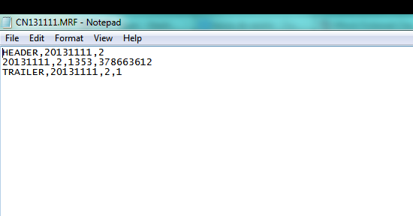

The Processor Company will respond with an SPF file containing the monthly credit card volumes of the merchant requested. Here is an example of an SPF file:

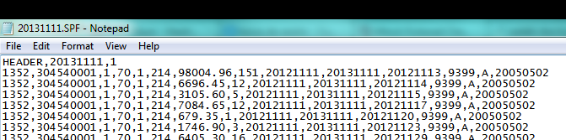

## List of Merchants Pending for Scoring

This should display a list of all the Merchants that have received the credit card volumes but have not yet been scored.

## Scoring Job, Merchant Evaluation and Offer creation

We now score the merchant and go on with the offer creation, which will be done in a calculator application. I will annex a replica of our current calculator done in Excel so you can see the formulas and logic that goes into it.

After we have received the Credit Card Volumes through the SPF file, the new task is going to be the Merchant Evaluation task. Here our officer will generate the score for the Merchant, take a look at the Datacrédito and the Credit Card volumes, and then decide whether to go to the Offer Creation task or decline the Prequalification. We want the system to show us a letter score or whatever scoring model will be used.

This is how the calculator currently looks:

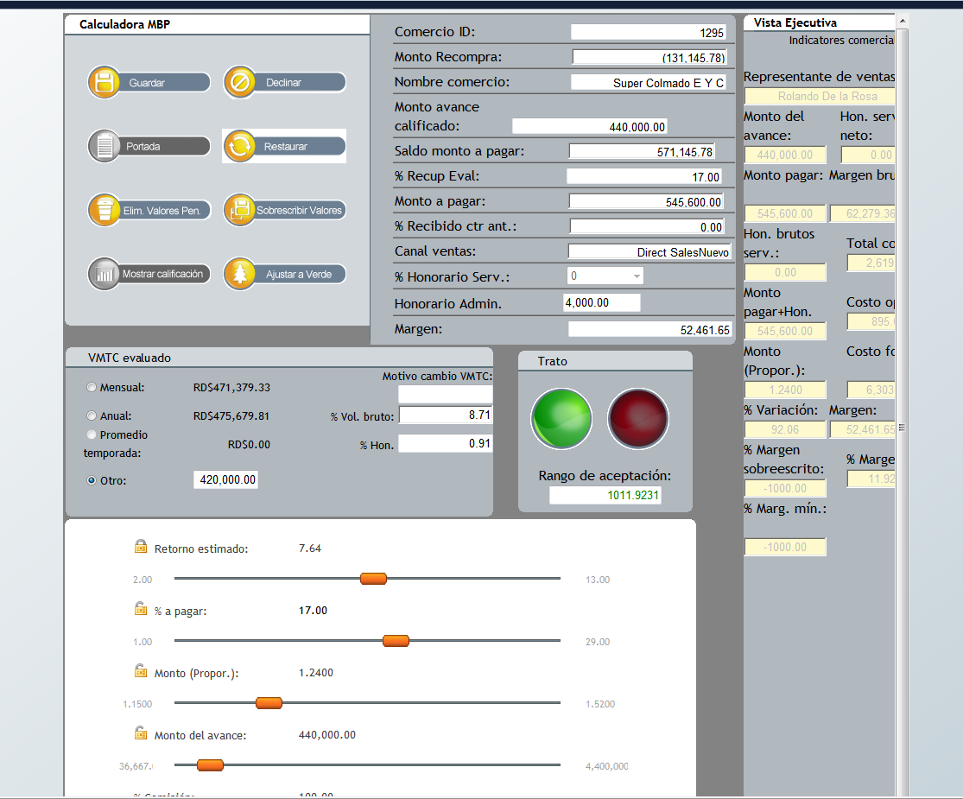

This is what we want it to have:



This should pull the Gross Yearly Sales automatically from the information entered in the Merchant Creations process, but it should let us change it manually in case we need to. The Average Monthly Credit Card Sales should be calculated from the volumes. It should also let us change in manually if we need to.

This is the Offer Calculator. The components of the offer are the Time in months the contract is expected to last, the loaned and owed amount, the proportion (This is the Owed Amount divided by the Loaned Amount, for example, if the loan is going to be 100, and the owed amount will be 150, then the proportion is 1.5) and the retention percentage, which is the fixed percentage we will be discounting from the credit card sales of the Merchant as payment. Every field should have sliders to move around the amounts until the officer is comfortable with the offer.

This button is to save the current offer, so that the officer can do more than one offer to present the client.

Here it should display all the saved offers and the details of the offers.

Once the officer has saved all the offers he needs to, he can hit complete or decline (as usual). If he hits complete, then the system should generate a PDF file with all the saved offers and the details. This is the file the officer is going to send the Sales Representatives so that they can present them to the client.

## List of Merchants Pending for Offer Acceptance

This should be another list where we have all the pending offers with the option to accept any offer and kick off the contract workflow.

## Additional Information

At all times we should be able to decline the Merchant and end the PQ process. Incluir Drop Down.

There should be a Note application, where we can write notes that will be stored in the Merchant and we will be able to access at all times.

We should have the ability to send back any Merchant from one step of the process to a previous step. We need to do this in case a certain step has been incorrectly completed.